PAM Map application allows you to see and interact with Instagram users on map in real time.

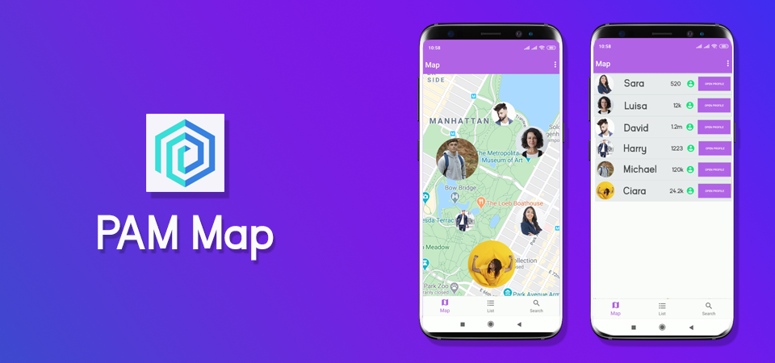

**Why we are unique?**

There are no applications similar to PAM Map that would allow Instagram users to see other Instagram users on map. Facebook does have a service called FriendsNearBy which allows Facebook users to see their friends’ locations on map but that’s really a small circle to choose. PAM Map not only shows your followers, or people you are following but ALL Instagram users that have chosen to be visible on map. In Order to show current users location we use Instagram profile picture, while Facebook just uses a regular marker to show position of your friend. You can also open users profile on Instagram by just taping on them.

**What’s the purpose of PAM Map?**

PAM Map simply allows Instagram users to see other Instagram users on map. It also helps you to find new people that might be interested in you, or find out where are your friends at and what are they doing right now. You can use PAM Map to find where your favorite artist/musician/actor is right now by just searching their nicknames. Are you visiting some extraordinary place and want to show everyone where you are right now? Then just open PAM Map, and everyone will see where you are.

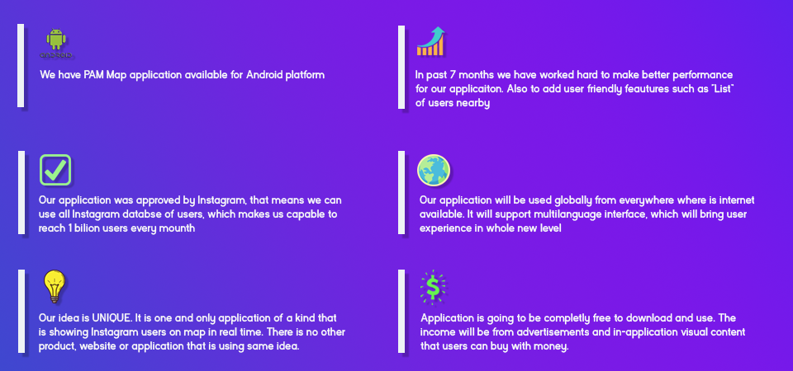

**What’s our goal?**

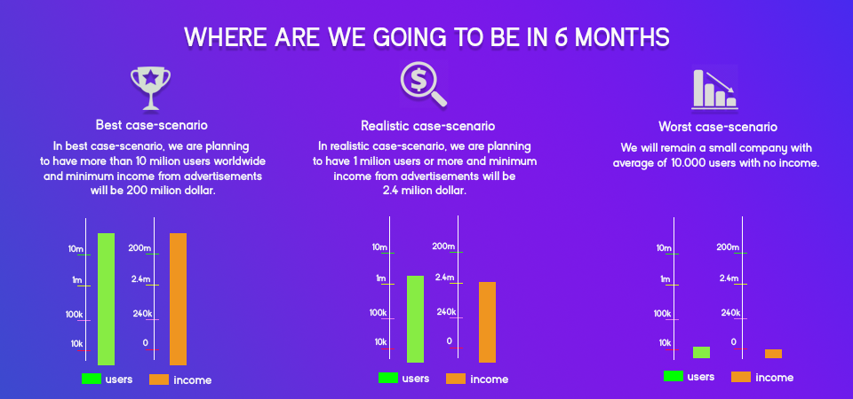

Our goal is to have a fast, multiplatform and user friendly application that millions of people will enjoy using every day. We have already established an android version of application and it’ll be available on play market soon. But we know that half of Instagram users if not more are using an iPhones, that’s why we are raising funds to make application for iPhone users too and so to have a great user experience.

**How are we going to use money?**

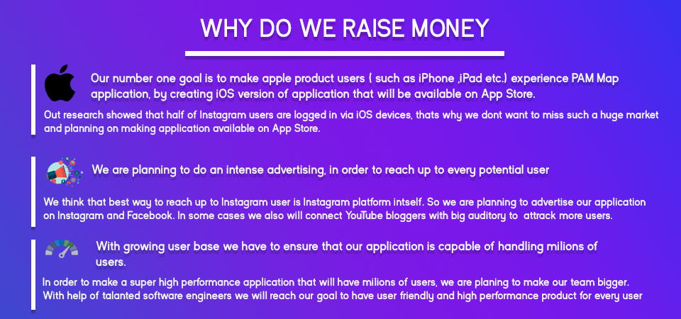

Number one priority for us right now is to make application for iOS (iPhone) users.

. 50.000 $ to create high performance, user friendly version of PAM Map application for App Store.

. 200.000$ for intensive marketing with Instagram, Facebook advertising. And also advertising via popular persons (such as bloggers on YouTube).

. 50.000 – 100.000$ for continuous integration of new features that will keep users interested and happy with PAM Map application.

**How are we going to make income?**

We are planning to integrate ads, when we reach 1.000.000 or more users. If 30% of 1.000.000 users will buy ads on PAM Map, then we will have 300.000 users who will pay us to have their advertisement. Users will have options for different price advertisements`

5 $ for 50.000 views

15 $ for 150.000 views

30 $ for 300.000 views

40 $ for 400.000 views

50 $ for 500.000 views

Or customizable price each 1$ for 10.000 views (so if user want to have 700.000 views he/she should pay 70$)

That means if we reach 1.000.000 users our income for lowest price advertisement will be 1.500.000$ which will already cover funds that we are planning to reach.

By getting more and more users by advertising our application we will have more income, and company value will only grow.

**What is our later plans?**

If we successfully conquer Instagram users fields, then we will be focused on delivering same experience of using PAM Map not only for Instagram users by for other social media too, for example Twitter, Facebook, Tinder and etc.

**Want to contact us?**

We would really love to see a support from you, so don’t hesitate to contact us with questions about investing or just to give us feedback by this email [razmik.gharibyan.olymp@gmail.com](mailto:razmik.gharibyan.olymp@gmail.com)